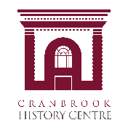

CAMAL
Annual General Meeting
April 30, 2021
6:30 PM

AGENDA

- Invocation:
“We would like to acknowledge that the Cranbrook History Centre is located on the Ktunaxa traditional territory and extend our gratitude for the opportunity to live and learn in mutual respect and appreciation”.

- Welcome, Introduction and Opening Remarks

- Adoption of Agenda

- Approval of the minutes of the Annual General Meeting held April 24, 2020

- Chair’s Report

- Executive Report
- Treasurer’s Report

- Appointment of Auditor for 2021

- Approval to amend the Constitution

- Approval to amend the Society Bylaws

- Election of Directors

- Motion to Adjourn

